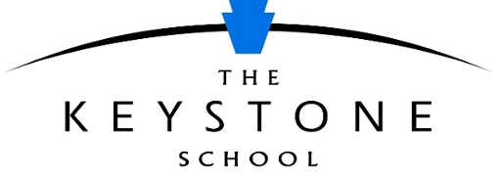

Scholarship Application Instructions

In addition to the completed and signed application form, all students applying for a K12 scholarship must submit the following materials:

- Student essays
- Grade point average (GPA) documentation: Official transcript or grade report documenting the student's cumulative GPA of 3.0 (letter grade B) or above
- Two letters of recommendation
- Parent Information Form
- Verification of household income for 2 years prior to current. (If available)
- Student video, audio recording, essay, or poem (see instructions and options below)

STUDENT ESSAY QUESTIONS
Provide written or typed responses to the following questions. Each response should be between 500–650 words and will be evaluated according to the Essay Rubric.
  - Recount a time when you experienced failure. How did it affect you and what lessons did you learn?

  - Choose a person or persons you admire and explain why.

  - What do you want to use your education to achieve? What are your goals after you graduate high school? How will an online education prepare you for future endeavors?

GRADE POINT AVERAGE DOCUMENTATION
Submit an official transcript or school grade report showing a cumulative grade point average of 3.0 (letter grade B) or higher. Official transcripts must be provided before a scholarship can be awarded, but for the initial application, you may submit unofficial documents and follow up with official GPA documents later. (Official documents are in a sealed envelope from the school and are marked “Official.”)

LETTERS OF RECOMMENDATION
Submit two letters of recommendation. The letters cannot be from family members. We suggest asking a teacher, adult family friend, community member, clergy, mentor, etc. Recommendation letters must address the following questions:
- How long have you known the student and in what capacity?

- How will the student benefit from this opportunity?

- What are the student's strengths?

- What skills does the student possess that will benefit him or her in an online setting?

PARENT INFORMATION FORM
The parent or legal guardian must complete the Parent Information Form.

HOUSEHOLD INCOME VERIFICATION
Submit the front page of your 1040 form for the past two years or submit copies of your W-2 forms for the past two years.

STUDENT VIDEO, AUDIO RECORDING, ESSAY, OR POEM
Students should create a short video, record an audio statement of three minutes or less, or write an essay or poem introducing themselves to the scholarship committee and expressing what receiving the scholarship would mean to them. Students should be as creative as possible while sharing the necessary information.
- If a video is created, share a link in the application materials.

- If an audio file is created, share a link or attach the file with the application materials.

- If an essay or poem is created, attach the file with the application materials.

SUBMISSION INSTRUCTIONS

Email application materials as attachments to KSAcademics@thekeystoneschool.net prior to enrollment in courses.

Applicants will receive an email acknowledgement that their materials were received along with a timetable of the application review process.

