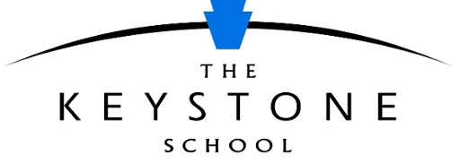

Parent Information Form
The K12 scholarship application requires a parent or legal guardian to write responses to the following statements. Please submit this form, with all other requested application materials, to scholarshipcommittee@K12.com by July 1, 2020, at 11:59 PM (ET).

- The Keystone School students need to become familiar with several online systems, use email frequently, be confident in working online, and be comfortable communicating effectively using technology. Please describe your student's technical abilities, including familiarity with using email and other online communication tools. Include your assessment of how well you feel your student could adapt to using the school's systems if he or she receives a thorough orientation and follow-up support.

- Student success in online education requires a partnership between the parent and school. Teachers will work with your student online to provide instruction and academic support as needed; however, because the student completes the work at home, an adult is needed to regularly monitor the student's work and progress, ensure the student is devoting enough time to school to succeed, and assist the student in requesting help from the school when needed. The designated adult (Learning Coach) will also receive orientation information and support to fulfill this role. Please identify who you think the Learning Coach supporting your student at home will be, how much time per week the Learning Coach would be available to spend supporting the student, and how prepared the Learning Coach is to fulfill this role if given the necessary training and support.

- Describe how you believe your child will benefit from receiving a scholarship to The Keystone School. Please be as specific as possible about your expectations regarding the impact this will have on your child's future.

- Please provide any additional information about your student's past school experiences or personal history that you feel would help the scholarship committee know your student.

